Student name : Sri Muthu Rajesh M

Student Id : S171165200405

Register Id : R171165200866

Batch Code : S160857

Git URL : <https://github.com/srimuthurajesh/RitchieStreet.git>

**Project Documentation**

**Introduction:**

This is an e-commerce project, domain-name as ritchiestreet.com, implemented all the features and functionalities that are required for a shopping website. It is build in Java platform.

**Versions used:**

Java version 1.8.0_91

maven version 3.3.9

Eclipse Mars2

Tomcat 8.0

**Technologies used:**

It is developed using following technologies:

Frontend - Html Css Bootstrap3, Javascript, jQuery, Angular js

Middle ware- Java8 javaEE, Spring4 Framework

Backend - Hibernate5, H2 Database

|  |  |
| --- | --- |
| Html | To make basic structure and layout for webpage |
| Css | To set the visual style of web pages and user interfaces |
| Bootstrap | To mobile first front end framework, makes website responsive |
| JavaScript | To provide dynamic interactivity on websites |
| jQuery | To implement event handling, animations in javascript |
| Angular js | To make single page applications |

Spring Framework:

It is called as framework of frameworks, (integrated framework) known for its loosely coupled characteristics and dependency injection IoC.

Hibernate Framework:

Hibernate is an object-relational mapping tool for the Java programming language. It provides a framework for mapping an object-oriented domain model to a relational database.

Basic operations:

|  |  |
| --- | --- |
| Admin operation: | Admin have seperate username password and can manage(edit, add, list, delete) the categories, suppliers details, and products. |
| User: | User can register as new user or can login using exist usrname and password. can see products and buy it. |
| Spring Security: | is a powerful and highly customizable authentication and access-control framework. |
| Add to cart: | products which are given as addtocart, does added to the user cart list |
| Webflow: | Spring Web Flow (SWF) is a component of the Spring Framework's web stack focused on the definition and execution of user interface (UI) flow within a web application. It is a module that allows you to make logical flows of your web application. |
| Multipart | Images upload feature using bytestream |

**Project Flow:**

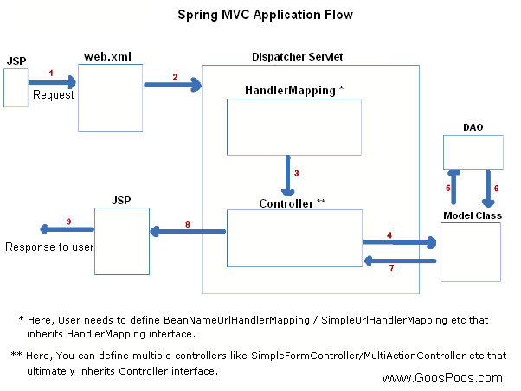

**Model** encapsulates the data related logic and it consist of POJO.

**View** is responsible for User interface logics, rendering the model data with webpage and generate output to the client browser to view page

**Controller** process all business logic and handles responses and request between model & view

* The flow starts from, when the client gives a request via url
* Dispatcher servlet which is called as front controller, receive the http request
* Using Handler Mapping, and call the appropriate controller associated with request
* Controller process the request by calling service methods and return ModelAndView
* ModelAndView object contains model data and view page name to dispatcher servlet
* With ViewResolver the prefix and suffix properties of viewpage appended to page name
* And With View interface renders the object to webpage
* Finally dispatcher servlet sent the view page to User

**Maven:**

It is a project management tool. Maven addresses two aspects of building software:

first, it describes how software is built, and second, it describes its dependencies management

It dynamically download java libraries and stores it in local cache

**List of jars used and its versions:**

spring-core: 4.3.5.RELEASE

spring-context:4.3.5.RELEASE

spring-webmvc:4.3.5.RELEASE

jstl:1.2

javax.servlet-api:3.1.0

jboss-logging:3.3.0.Final

junit:3.8.1[test]

h2:1.4.193

hibernate-core:5.2.5.Final

hibernate-jpa-2.1-api:1.0.0.Final

spring-orm:4.3.3.RELEASE

slf4j-api:1.7.21

slf4j-simple:1.7.21

spring-web:4.3.5.RELEASE

validation-api:1.1.0.Final

hibernate-validator:5.3.4.Final

spring-beans:4.3.5.RELASE

spring-security-config:4.1.4.Final

spring-security-taglibs:4.1.4.Final

spring-security-web:4.2.1.RELEASE

commons-fileupload:1.3.2

commons-io:2.5

commons-dbcp2:2.0

spring-webflow:2.4.4.RELAESE